http://evosuite.org/files/tutorial/Tutorial_Maven.zip(unzip it)

cd Tutorial_Maven

mvn compile

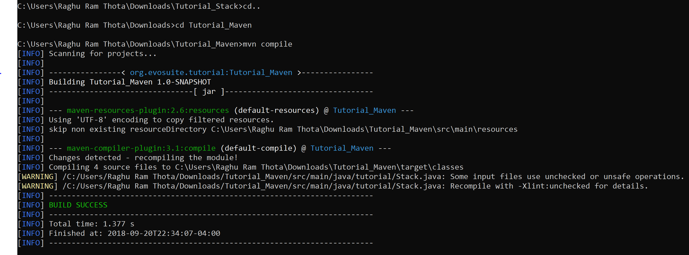

mvn test

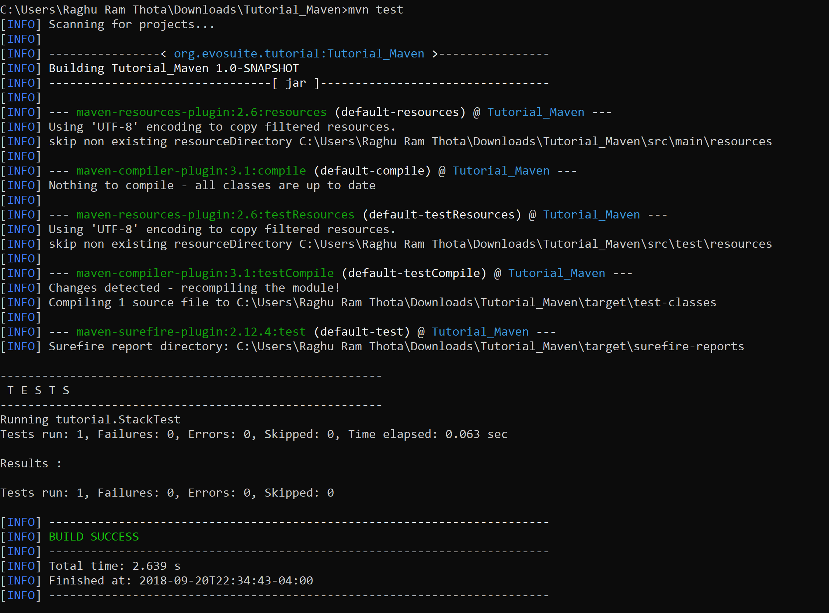

Add after </dependencies>

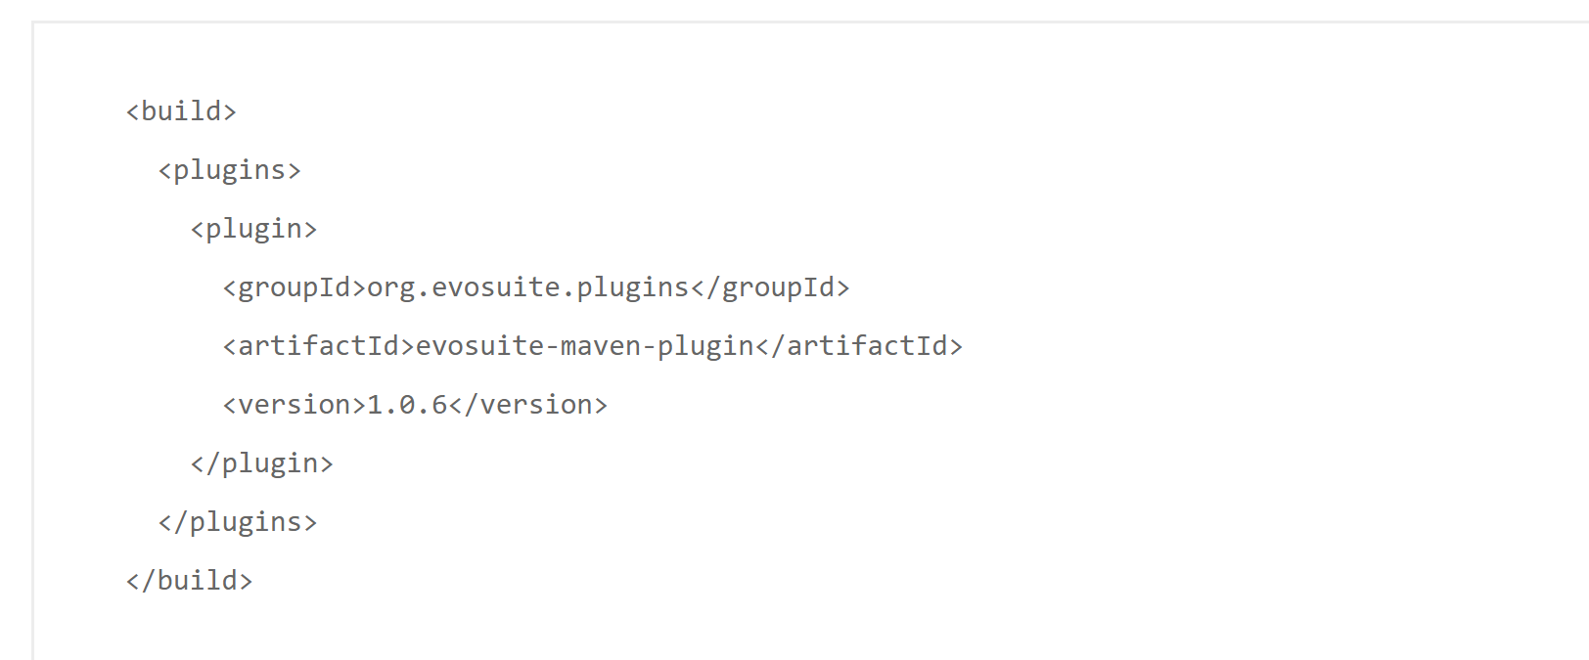

Add after </build> and befor</project>

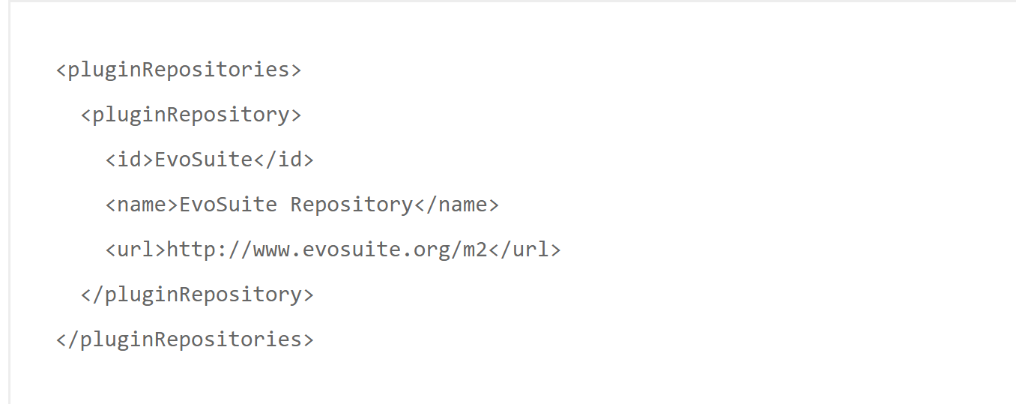

mvn evosuite:help

(after this there will be many lines of downloading …. And then below screen shot).

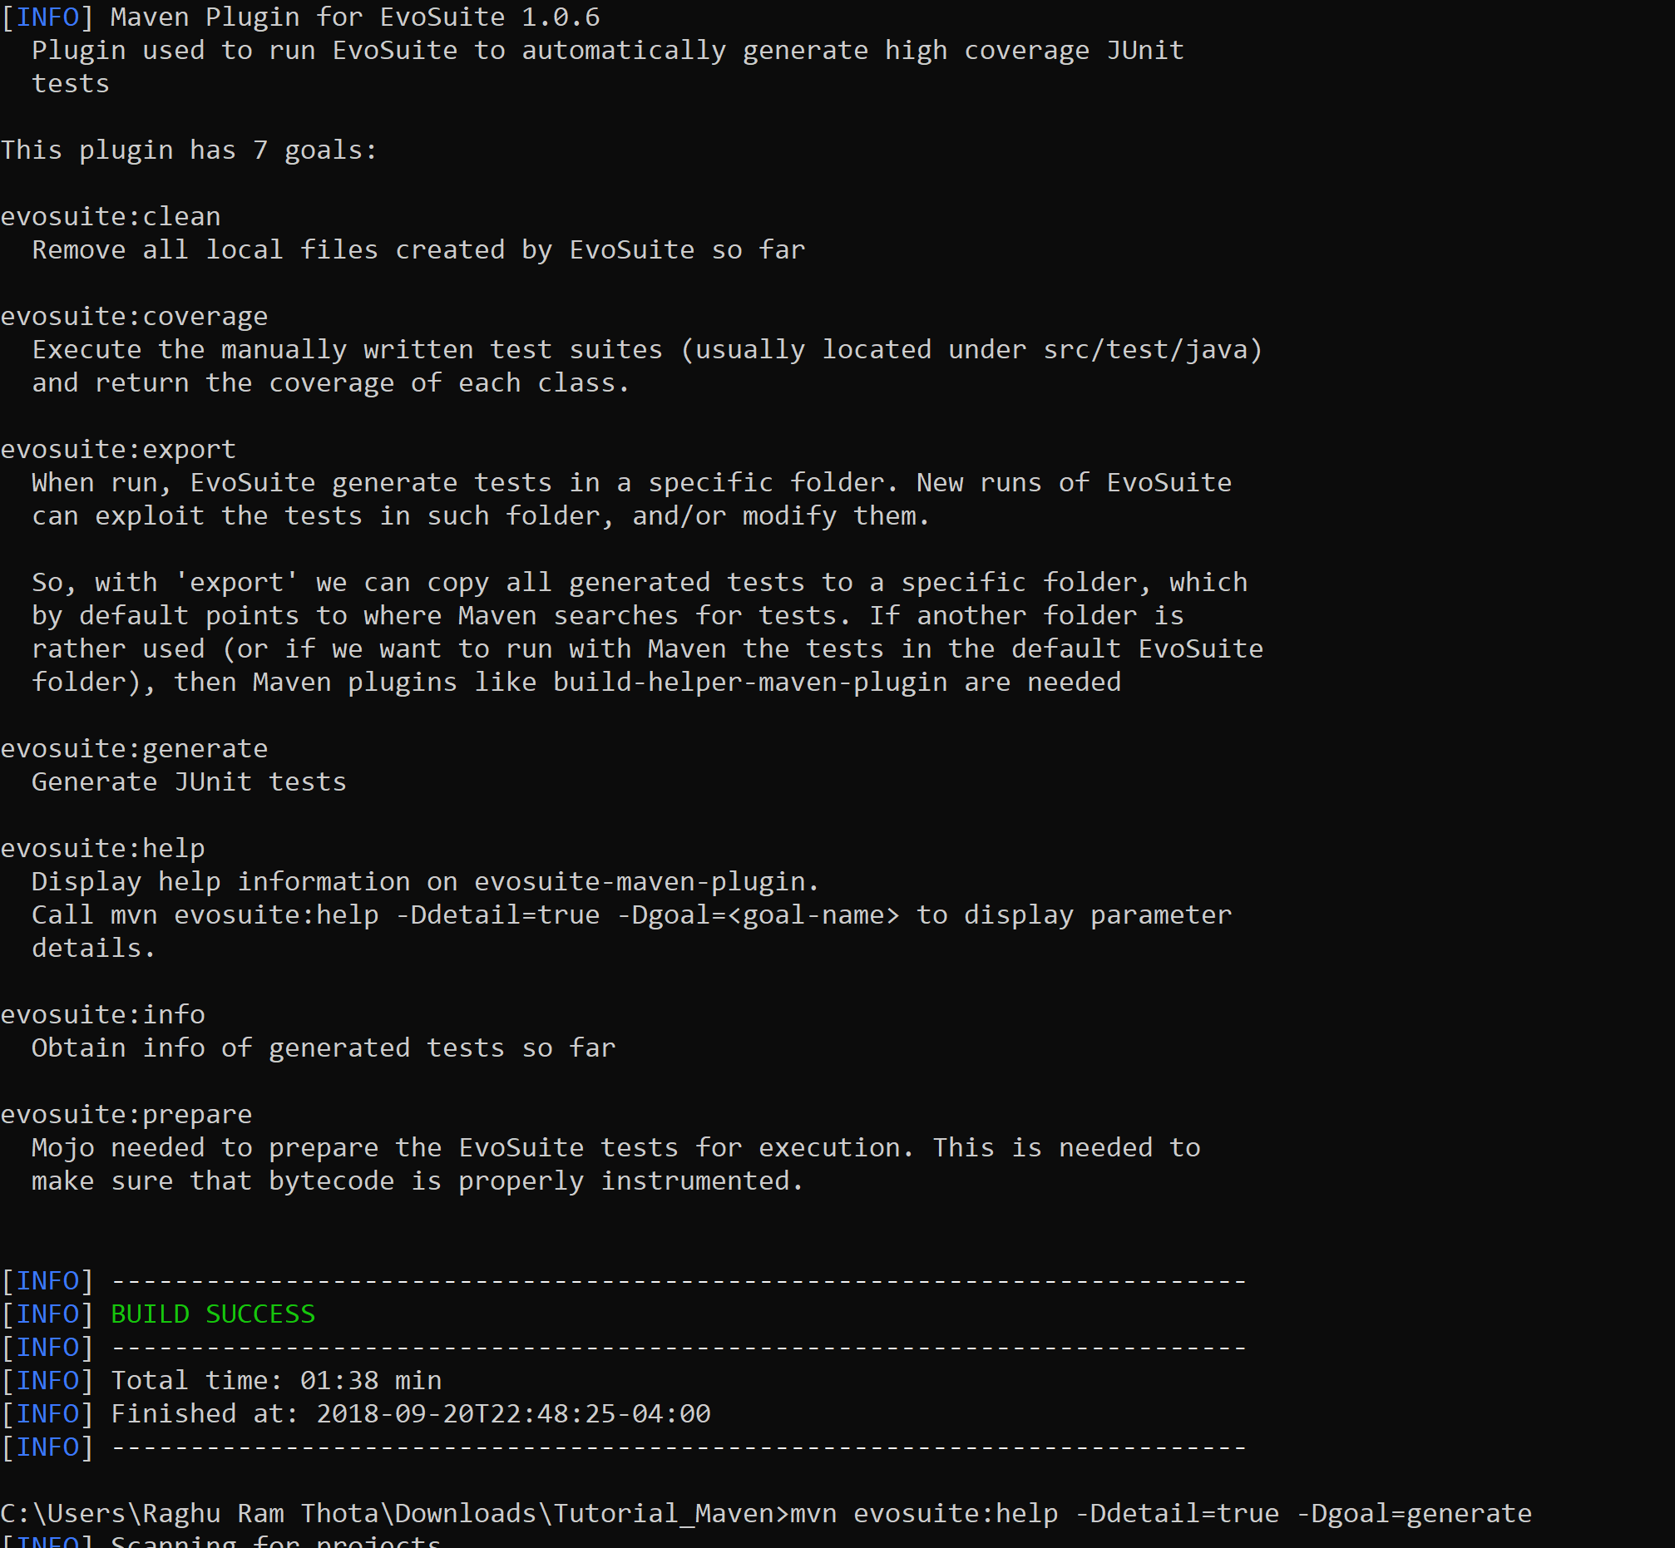

mvn evosuite:help -Ddetail=true -Dgoal=generate

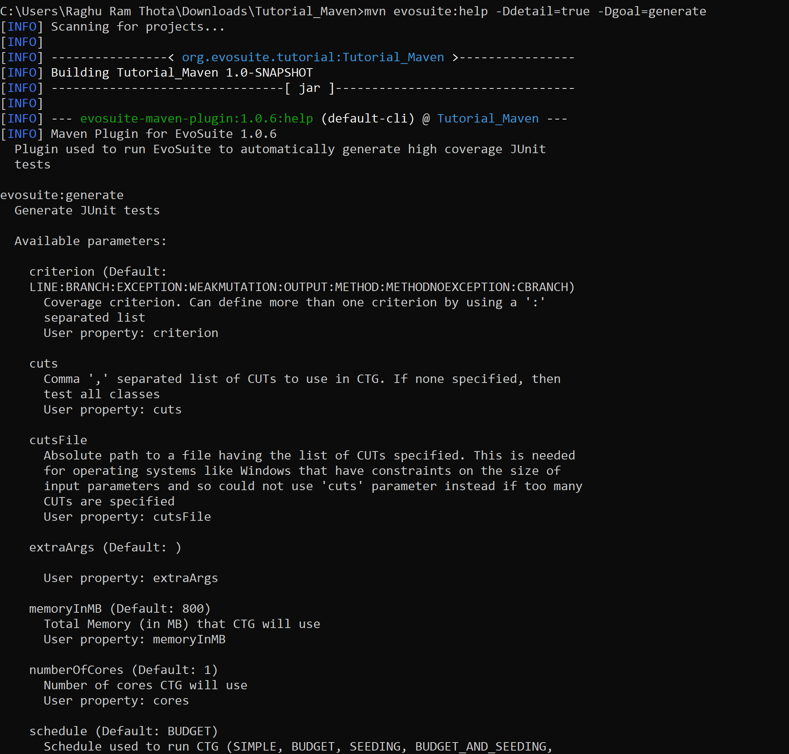

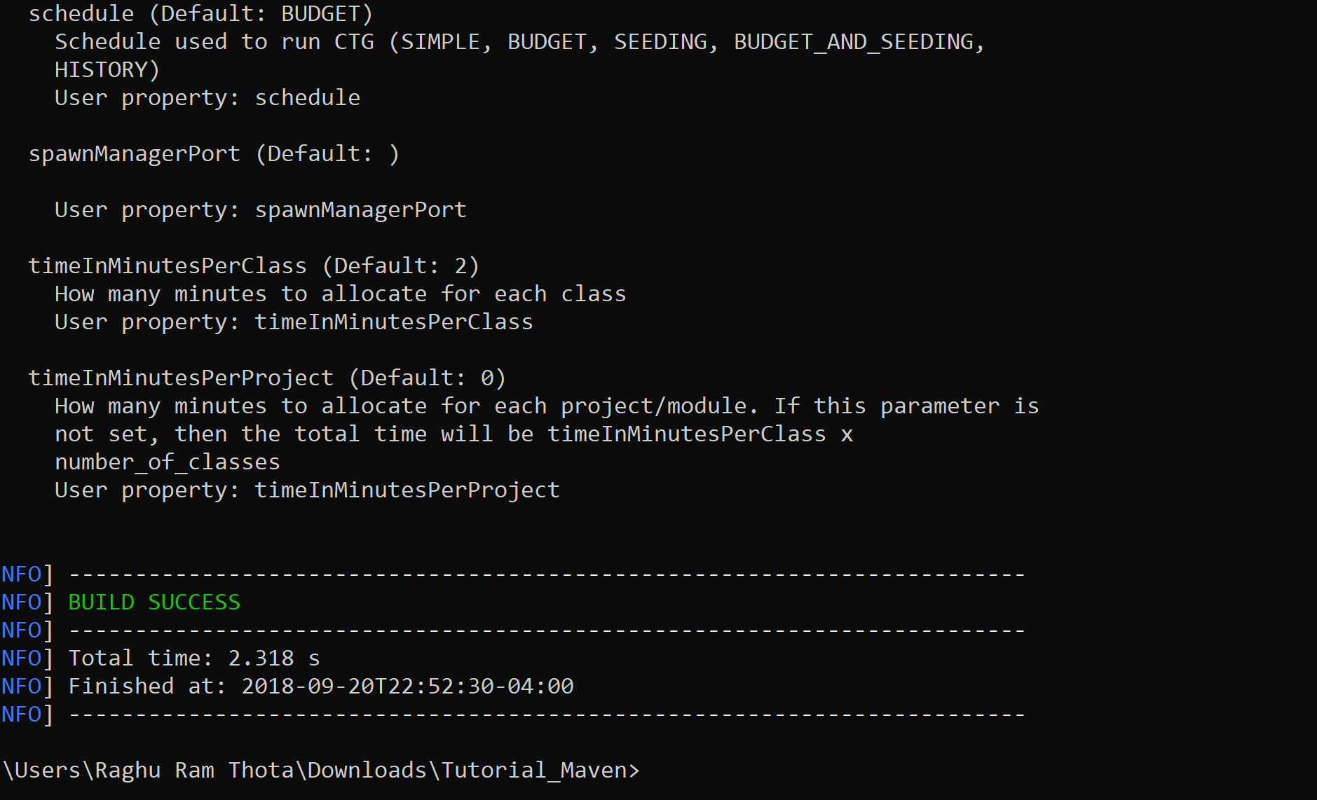

mvn evosuite:generate

(it will take 3-4 min)

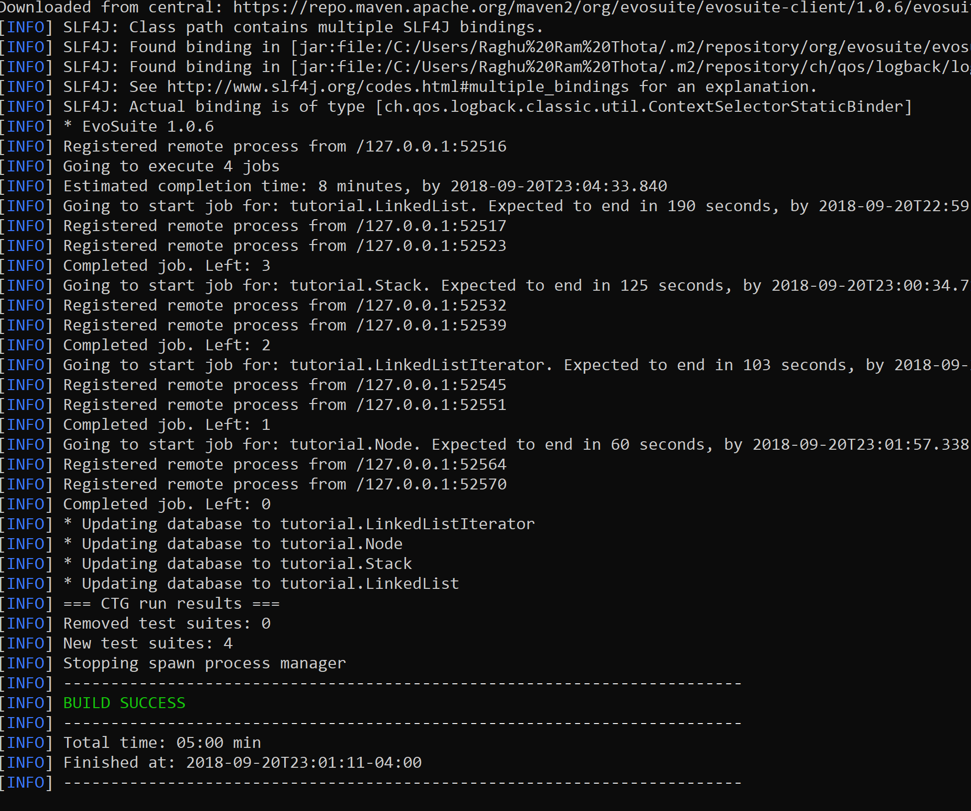

mvn -Dcores=4 evosuite:generate

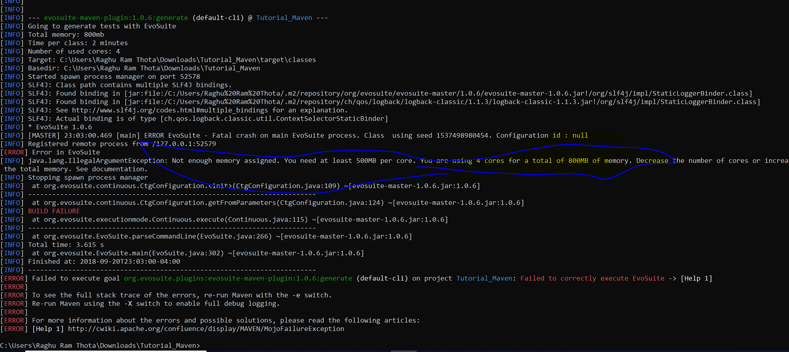

mvn evosuite:info

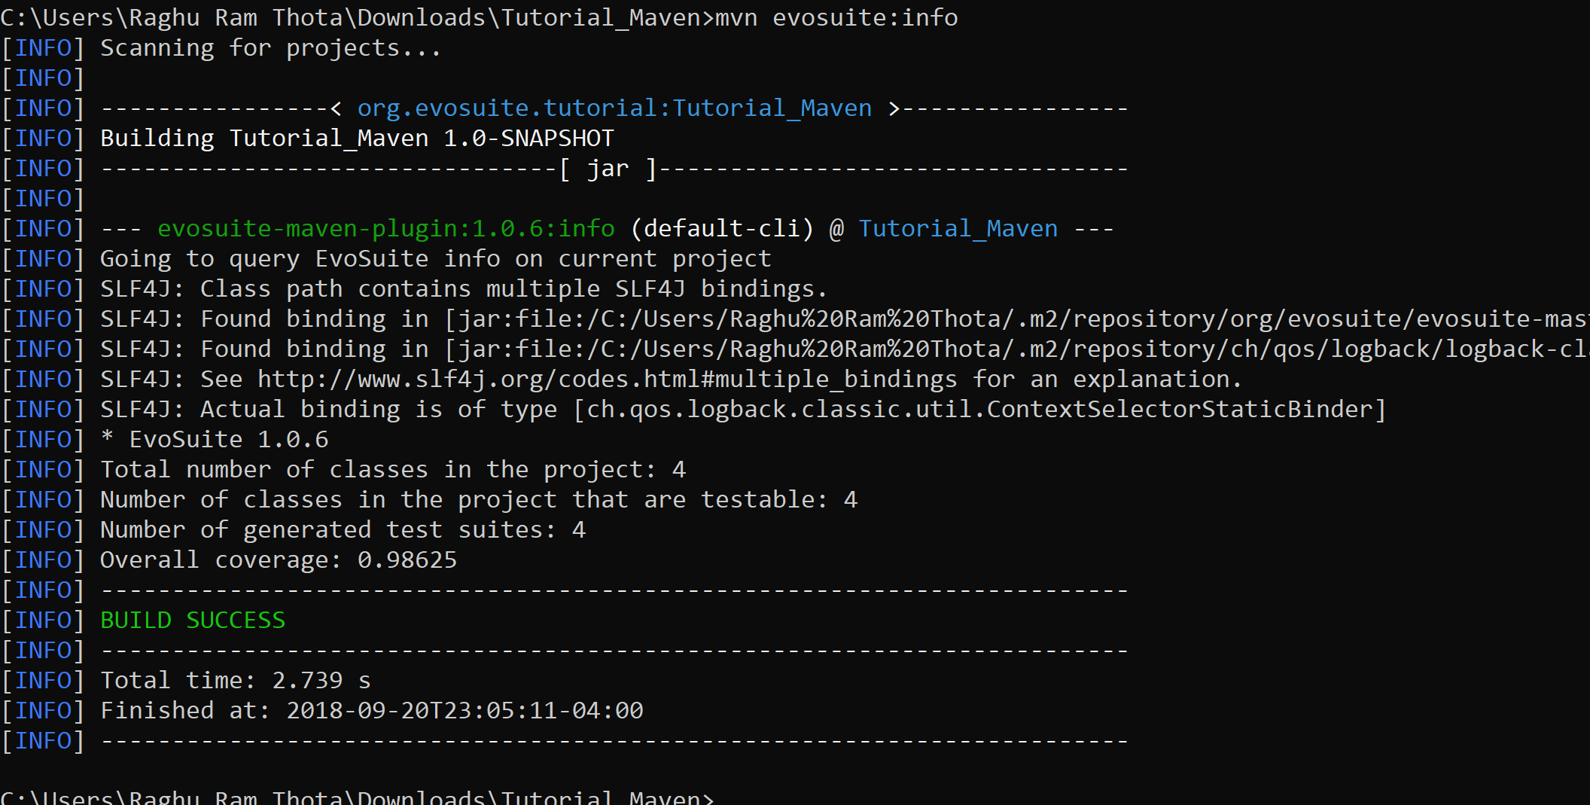

ls .evosuite/best-tests/tutorial(not for windows, in windows see below image)

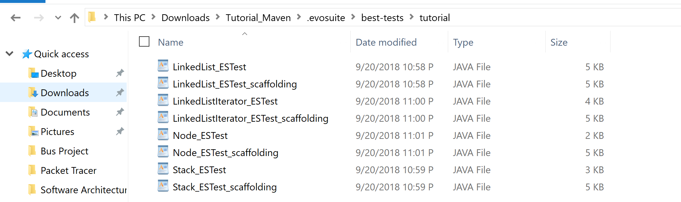

mvn evosuite:export

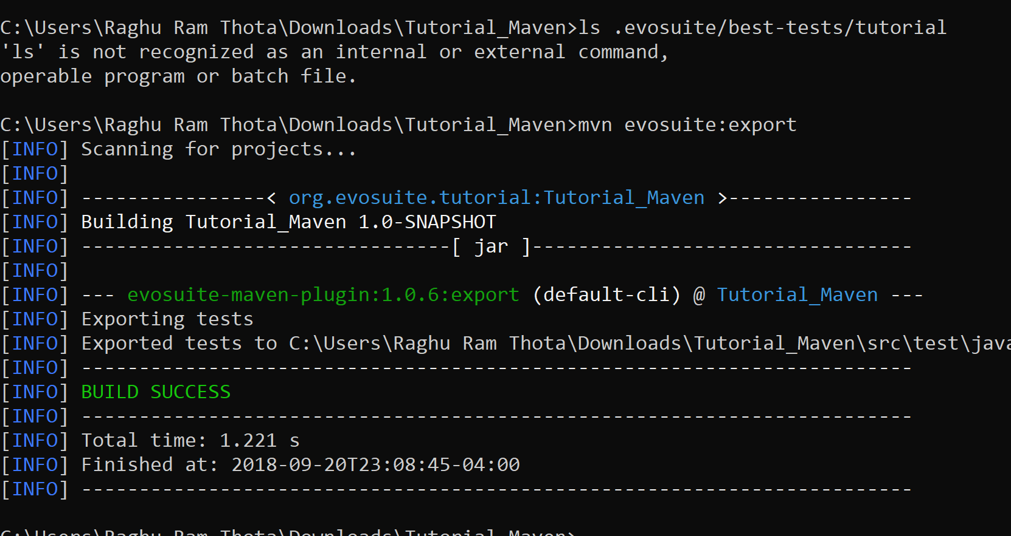

<dependency>

<groupId>org.evosuite</groupId>

<artifactId>evosuite-standalone-runtime</artifactId>

<version>1.0.6</version>

<scope>test</scope>

</dependency>

mvn test

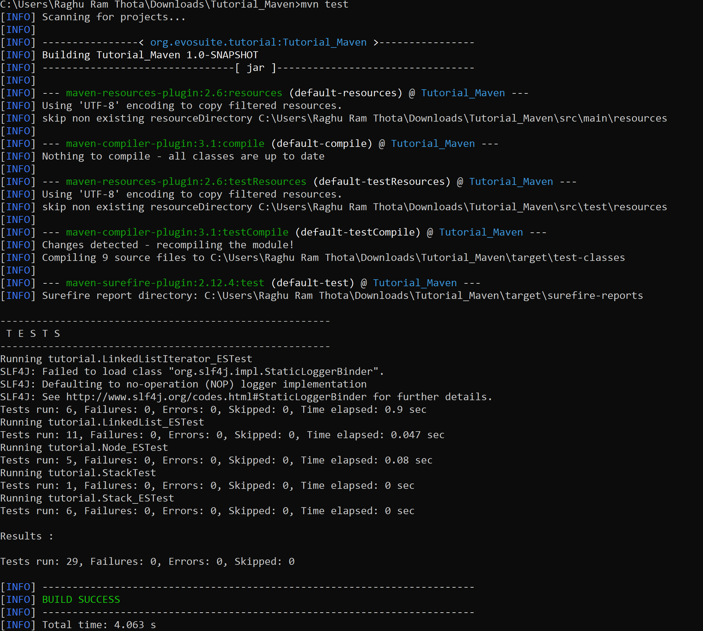

mvn evosuite:help -Ddetail=true -Dgoal=export

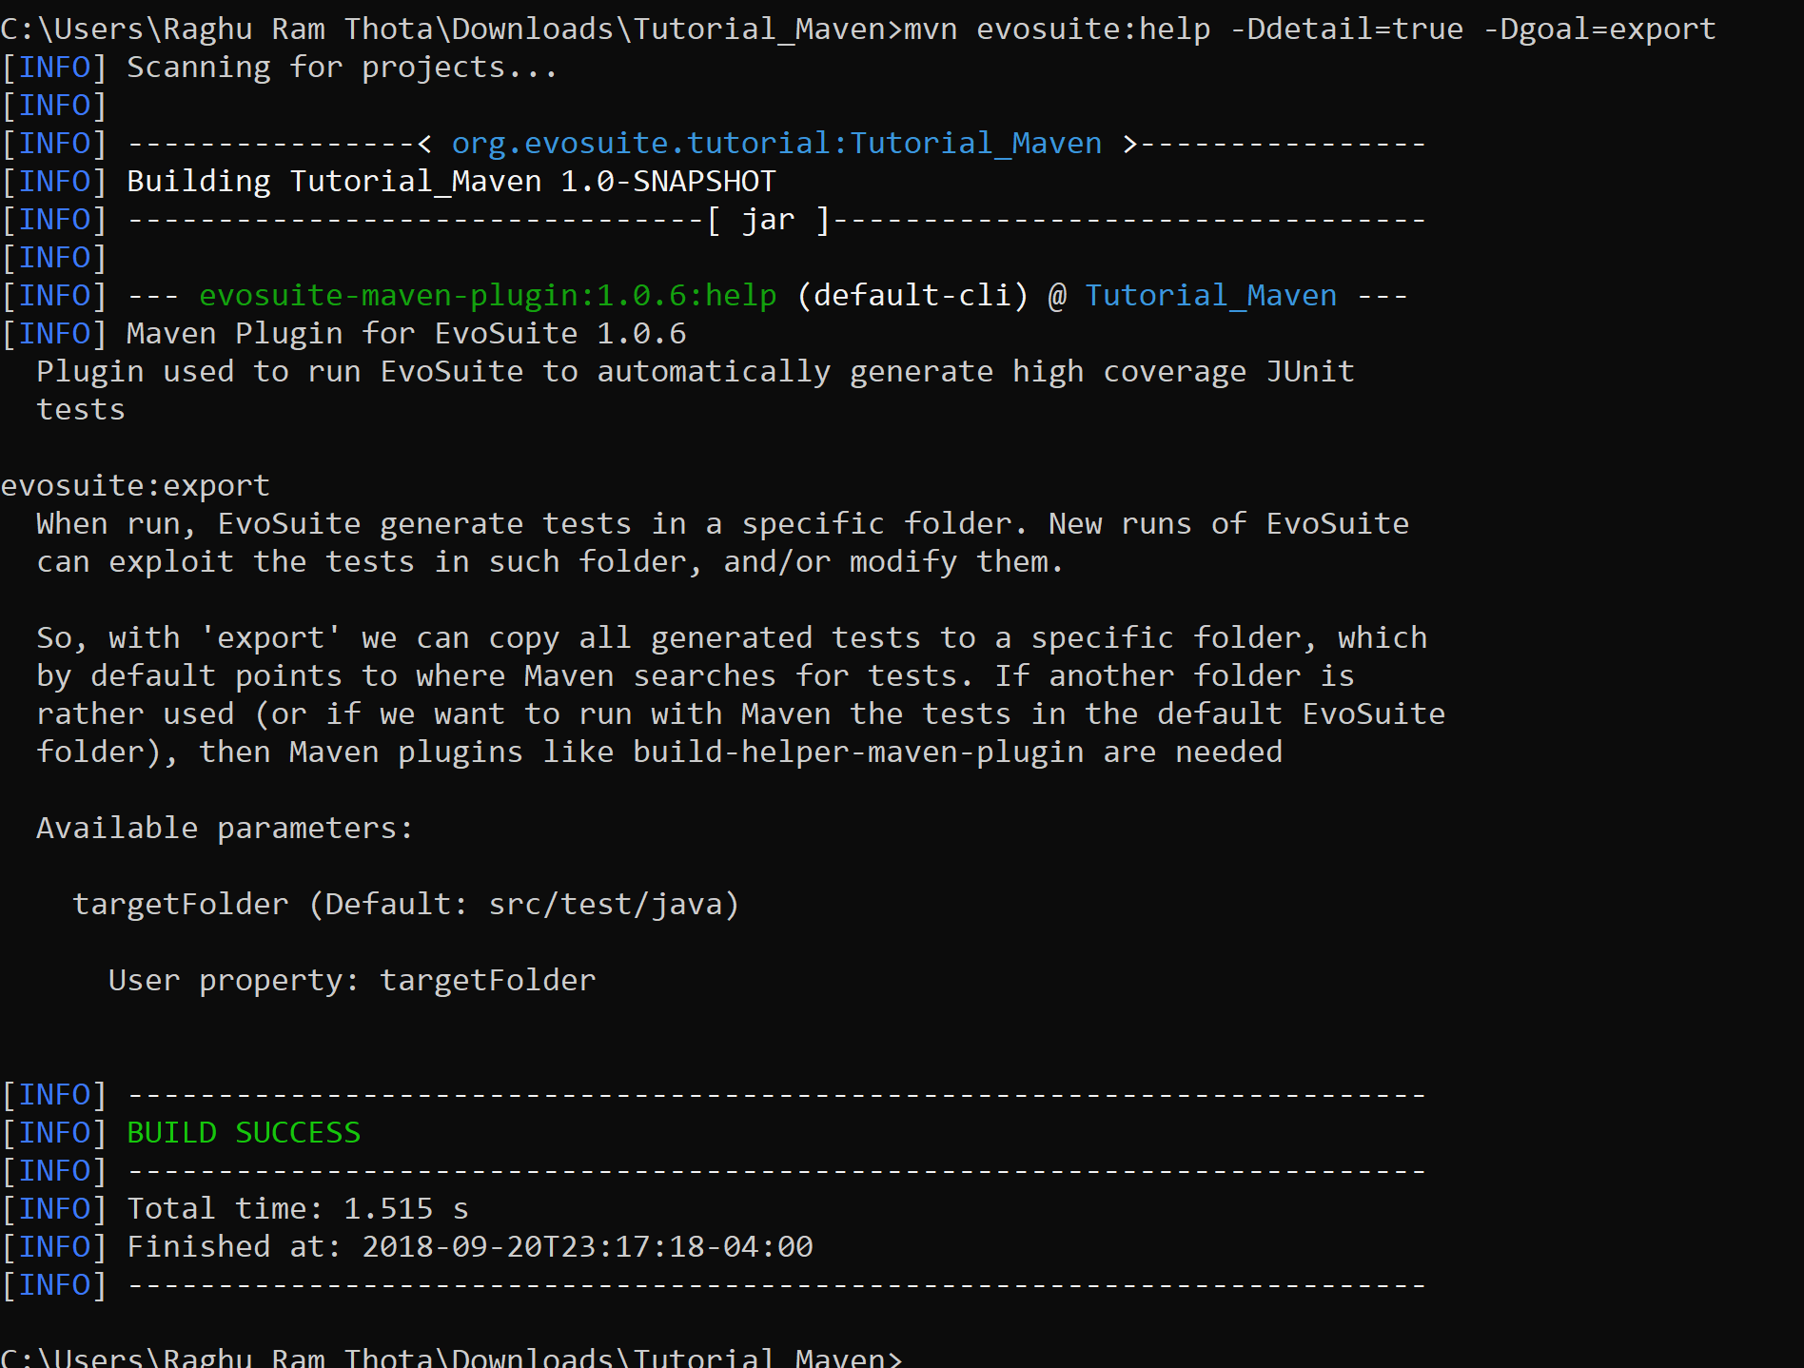

mvn evosuite:export -DtargetFolder=src/test/evosuite

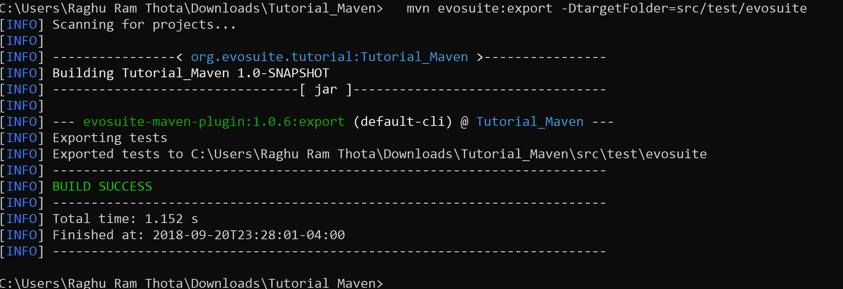

mvn evosuite:export

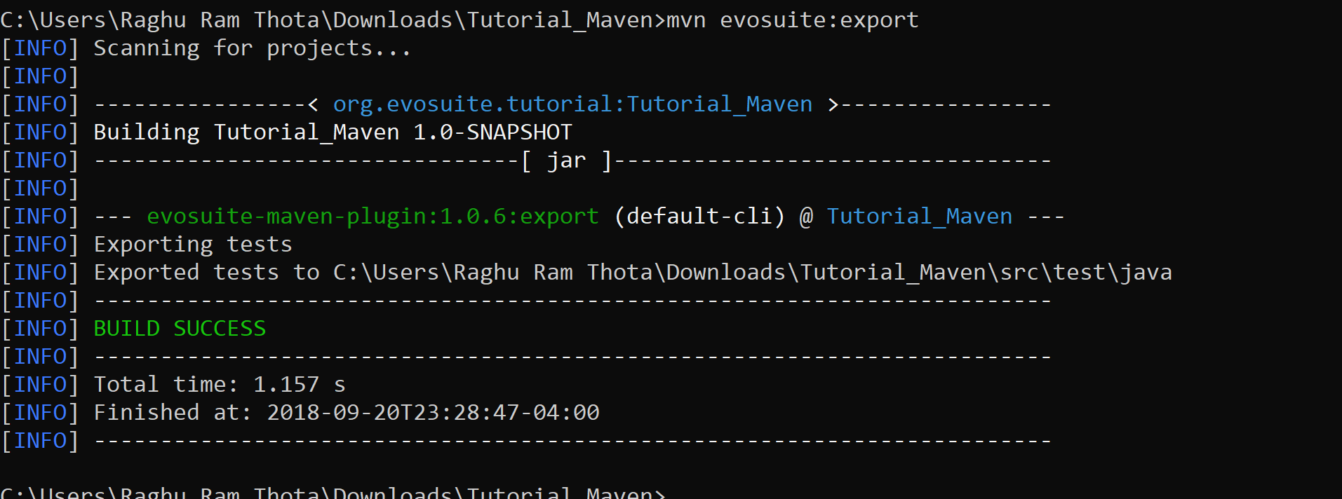

<targetFolder>src/test/evosuite</targetFolder> paste in properties (remove *ESTest* from src/test/java(try))

mvn test

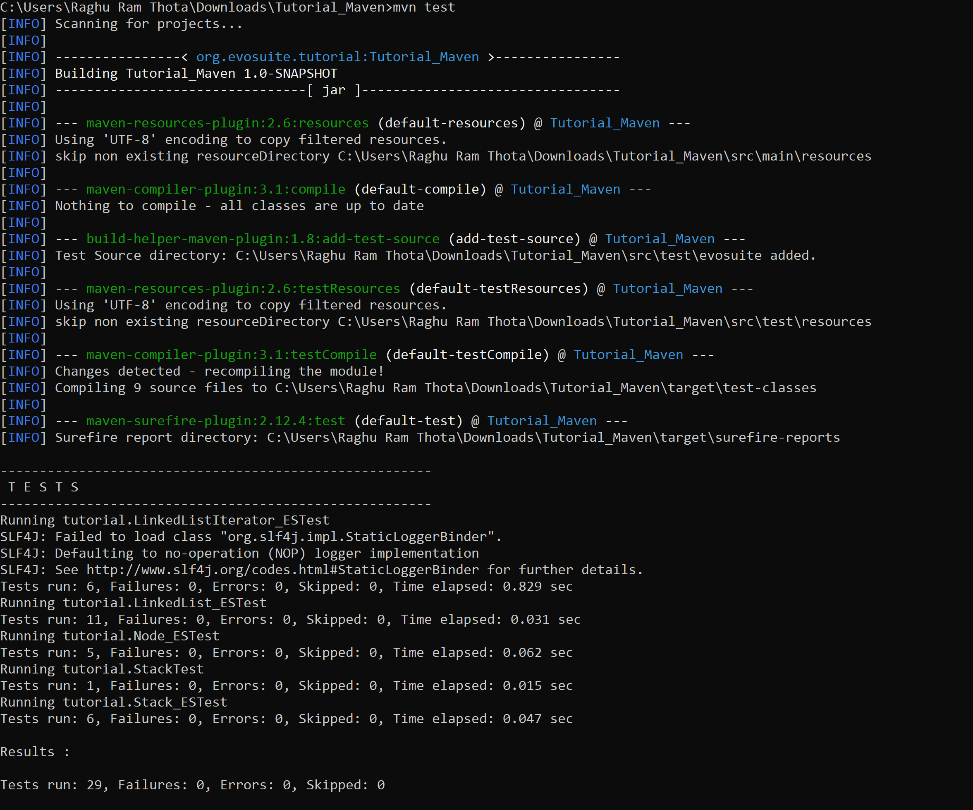

<plugin>

<groupId>org.apache.maven.plugins</groupId>

<artifactId>maven-surefire-plugin</artifactId>

<version>2.17</version>

<configuration>

<properties>

<property>

<name>listener</name>

<value>org.evosuite.runtime.InitializingListener</value>

</property>

</properties>

</configuration>

</plugin>

Add this in <build>